 |  |  |  |  | Responsible Department. | CTR Europe GmbH
 |  |  |  |  | Review cycle | 6 Months
▣ Contents  - Purpose  - Applying scope  - Definition of terms  - Responsibility Authority  - Working process  - Forms | Initiator | Reviewer | Head of team | Agreed
 |  |  |  | Received
 | Head of department | CSO/CPO | CEO
 |  |  |  | Reference

History | Number | Date | Scope of changing |  | Rational of revision | Description of revision | Written by
 |  |  | Partial | Overall
 | 0 | 2019-08-01 |  | ● | New |  | Sangmok Lee
 | 1 | 2021-03-11 | ● |  | Revision of working process | German tax law reflection and form addition | Youngjin kim
1. Purpose
This regulation has been prepared for employees working for CTR Europe GmbH (hereinafter referred to as the "Company"). The purpose of this travel expense regulation is to clarify all matters related to the payment standard of travel expenses incurred when an employee leaves a major workplace to work domestically and abroad for the purpose of performing work.

2. Applying scope
2.1 This regulation applies to all employees working for companies within the scope of the German Labor Standards Act (hereinafter referred to as the “law”).
2.2 Types of travel and travel expenses
- Domestic business travel - Travel expenses for domestic business travels
- Overseas business travel - Travel expenses for overseas business travels
- Education travel
2.3 Travel expenses can be classified into transportation expenses, accommodation expenses, and travel allowances.

3. Definition of terms
3.1 Business travel
It means that an employee goes to a workplace other than the main workplace on a temporary basis according to the job performance or the company's name,
and refers to the case when the employee stays for more than one night. This includes not only job performance, but also events, meetings, and
becoming company representatives that are directly related to company work.
3.2 Outside working
This refers to cases where you go to a workplace other than your main workplace and return back after finishing work on the same day.
3.3 Education travel
This refers to the case of returning to company after training from a work-related training center or educational institution.
3.4 Transportation expenses
It refers to the expenses of public transportation and the cost of using a private vehicle incurred for moving during business trips and outside work.

3.5 Accommodation expenses
This refers to the expenses required for accommodation while conducting business travels.
3.6 Travel allowance
This is an expense paid daily to pay for living expenses (food, beverages, etc.) incurred while performing business travels and outside working, and this follows
the country-specific table described in the German Government's Travel allowance and tax guideline. The document is also attached together as a form.
(Bundesministerium der Finanzen, 03.12.2020)
3.7 Special support for living abroad
Long-term overseas business travelers who must live abroad for a long time are provided with a special support such as the purchase of daily necessities.

4. Responsibility authority
4.1 The company maintains various systems related to business trips as stipulated in this regulation, and the overall responsibility and authority to operate are belong to the
company representative.
4.2 Responsibility and authority for the payment and redemption of travel expenses belongs to the company's financial department.
4.3 The traveler is responsible for knowing the applicable regulations for the correct use and claim of travel expenses during business trips and outside work.

5. Working process
5.1 Transportation expenses billing
5.1.1 Travel expenses incurred by bus and train/subway for business trips and outside work are treated on an actual expense basis.
5.1.2 If it is difficult to use public transportation(bus/subway), traveler can use a taxi, and it is approved by clearly checking with the authorized person whether or
not about the necessary taxi using.
5.1.3 When using a corporate vehicle, a “vehicle operation log” is recorded, and fueling of the vehicle is charged at a nearby gas station, and expenses are processed
in accordance with accounting regulations.
5.1.3 When an employee uses his/her vehicle, the amount calculated in consideration of the depreciation and travel distance of the personal vehicle's business use
is paid.
5.1.4 When using personal vehicle, compensation is based on the standard of 0.3 EUR/1km for the travel distance. Travel distance is calculated from the departure point
of the business trip to the return of the business trip.
5.1.5 Tolls and parking expenses incurred in the case of business travels or outside work by vehicle are considered as travel expenses.
5.1.6 When it is necessary to travel by air, such as when it is not possible to use trains, or when it is necessary to travel by air, such as accompanied by a customer,
and then the approving authority clearly confirms the necessity of using the air and proceeds the economy seats with approval.

5.2 Domestic accommodation fee (In Germany)
5.2.1 In the case of accommodation fees, actual expenses are treated within the range of the standard amount, and expenses outside the standard amount
are only treated up to the standard amount.
5.2.2 The standard for accommodation fee in Germany is 130 EUR/day regardless of the working position.

5.3 Overseas accommodation fee (Outside of Germany)
5.3.1 In the case of accommodation fees, actual expenses are treated within the range of the standard amount, and expenses outside the standard amount
are only treated up to the standard amount.
5.3.2 Overseas accommodation fee is applied at 140 EUR/day in European countries other than Germany and 160 EUR/day in Asia & America,
regardless of the working position.

5.4 Travel allowance (In Germany)
5.4.1 This is an expense paid daily to business travelers to pay for living expenses (meals, beverages, etc.) incurred while performing business travels
and outside work.
5.4.2 The expenses are paid to the traveler in accordance with accounting regulations after approval of the travel expense report after the business travel is over.
5.4.3 The standard for daily travel allowance is applied as follows in accordance with the German tax law.
- Same-day business travel, less than 8 hours: None
- Same-day business travel, over 8 hours: 14EUR/1 day
- On business trips for more than 1 day, on the day of departure and arrival: 14EUR/1 day
- On business trips for more than 1 day, business days excluding the day of departure and arrival: 28EUR/1day
- When meals are provided on a business travel day, the rest of the daily expenses are paid for breakfast/lunch/dinner 20%/40%/40% discounted.

5.5 Travel allowance (Outside of Germany)
5.5.1 This is an expense paid daily to business travelers to pay for living expenses (meals, beverages, etc.) incurred while performing business travels
and outside work.
5.5.2 The expenses are paid to the traveler in accordance with accounting regulations after approval of the travel expense report after the business travel is over.
5.5.3 The standard for daily travel allowance is different from country to country according to German tax laws.
- Same-day business travel, less than 8 hours: None
- Departure date, arrival day and over 8 hours: Form#1. Table of Travel Daily Allowance by Country referred
- When meals are provided on a business travel day, the rest of the daily expenses are paid for breakfast/lunch/dinner 20%/40%/40% discounted.

5.6 Education travel
5.6.1 Education travel can be divided into “domestic training” at educational institutions in Germany/Europe and “overseas training” at educational institutions
outside of Europe.
5.6.2 ‘Domestic training’ receives support for transportation, accommodation, and travel allowance that are the same as the standard for business trips
in Germany.
5.6.3 If transportation, accommodation, and meals are provided in the educational program, employee cannot claim the expenses of travels during the program period.
5.6.4 However, employee may claim for expenses incurred when moving after attending or completing the educational program.
5.6.5 If transportation, accommodation, and meals are provided within the ‘Overseas Training’ program, employee cannot claim the expenses during that period.
5.6.6 However, employee may claim for expenses incurred when moving after attending or completing the training program.

5.7 Business travel preparation and termination procedures
5.7.1 When going on a business trip, a business trip plan must be prepared and approved. In the case of a domestic business trip, a business trip report is submitted
after the business trip and travel expenses are paid by company.
5.7.2 Business travelers must depart after checking the transportation and accommodation environment of the business travel destination.
5.7.3 In case the credit card cannot be used during a business trip abroad, or to be paid in cash, employee can apply for a prepayment.
5.7.4 Prepayment cash must be approved within the business travel plan report, and should be received 2 days prior to departure date after approval by
the finance department.
5.7.5 When the business travel is over, the traveler submits the business travel report and travel expense report (form #2, trip expense report) to the finance
department with evidence (receipt, invoice, etc.) attached.
5.7.6 The details of the travel expense report are reviewed by the finance department, and it is processed only for expenses that meet the purpose of the travel.

6. Forms
#1. Table of Travel Daily Allowance by Country
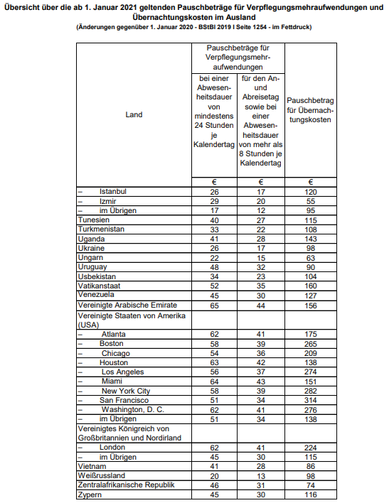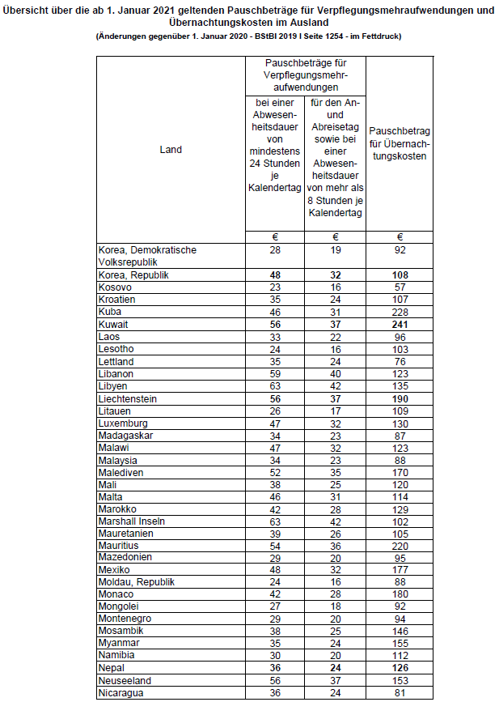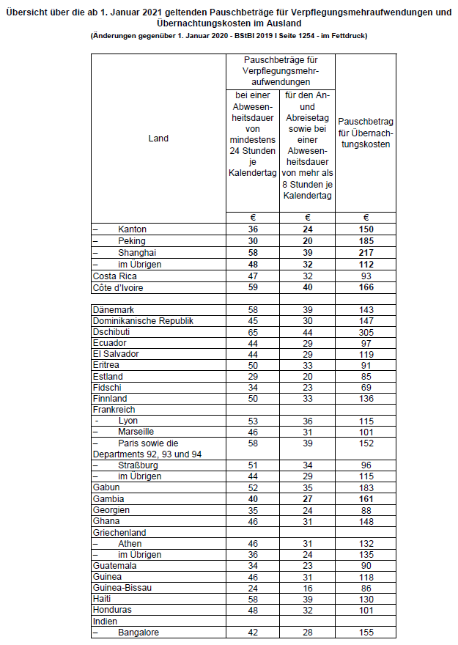
#Form 2. Travel expense report

#Form 3 Corporate vehicle mileage logbook

